**III. BUILD AND EVOLVE AGILE TEAMS**

Introduction

Lesson Introduction

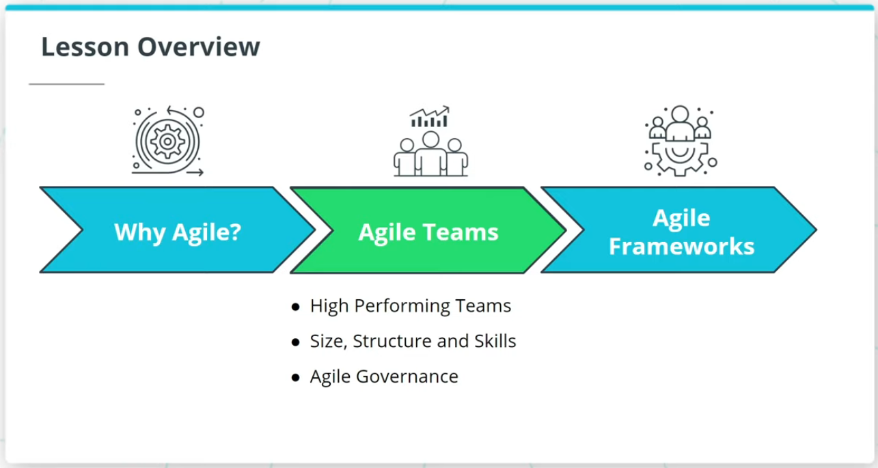

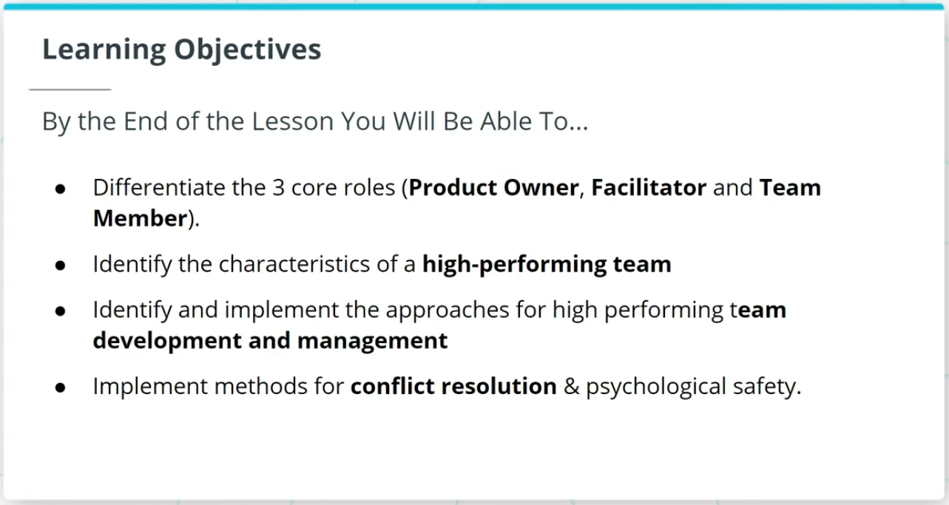

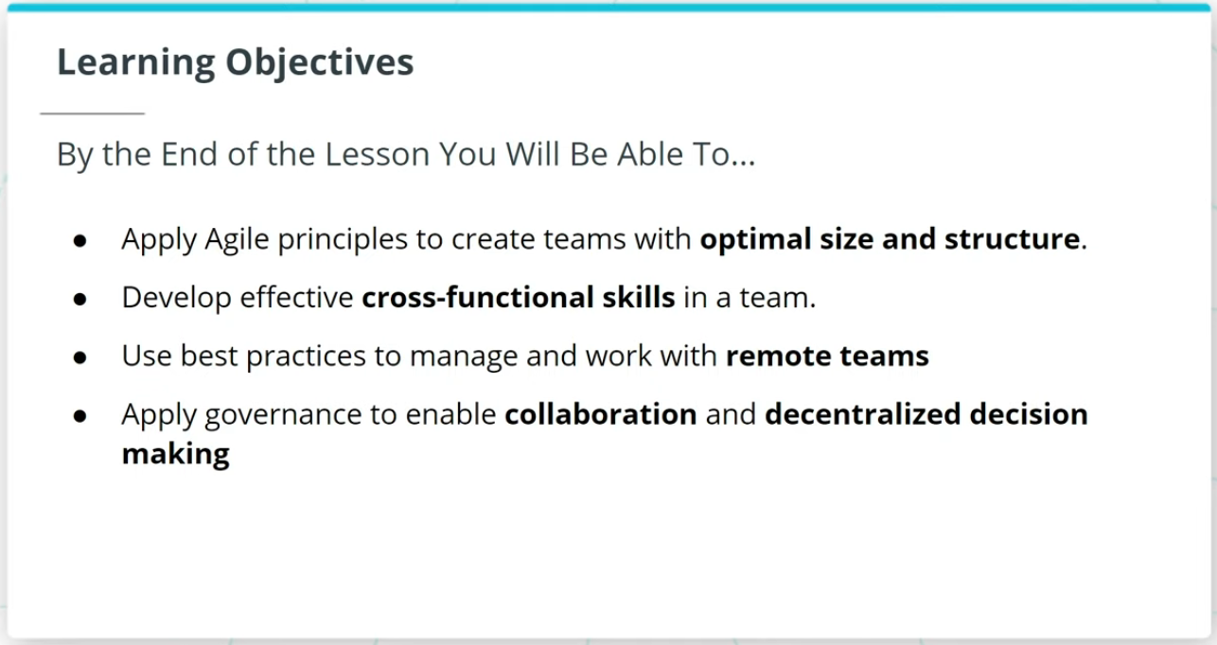

Welcome to a lesson on Agile Teams. In the last lesson, we talked about the importance of Agile.

This lesson will cover the following key topics:

### **High Performing Agile Teams**

* How Agile Teams are the vehicle that delivers valuable work tied to business-driven product features and functionality.
* Characteristics of a high-performing Agile Team.
* How to sustain High Performing Teams.

### **Size, Structure, and Skills of an Agile Team**

* The 3 core roles in Agile.
* An Agile Team’s optimal size, structure, and cross-functional skills.

### **Agile Governance**

* Agile Governance and how Agile governance leverages The Agile Manifesto’s guidelines to balance assurance with adaptability.

### **By the End of the Lesson, You Will Be Able To...**

* Differentiate the 3 core roles (Product Owner, Facilitator, and Team Member)
* Identify the characteristics of a high-performing team
* Identify and implement the approaches for high performing team development and management
* Implement methods for conflict resolution & psychological safety
* Apply Agile principles to create teams with optimal size and structure
* Develop effective cross-functional skills in a team
* Use best practices to manage and work with remote teams
* Apply governance to enable collaboration and decentralized decision making

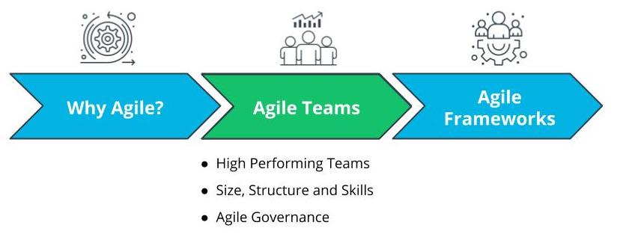

Lesson Overview - Agile Teams

# Why Agile Teams?

## Why Do Agile Teams Matter?

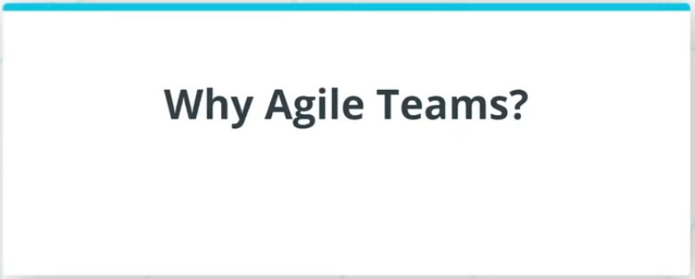

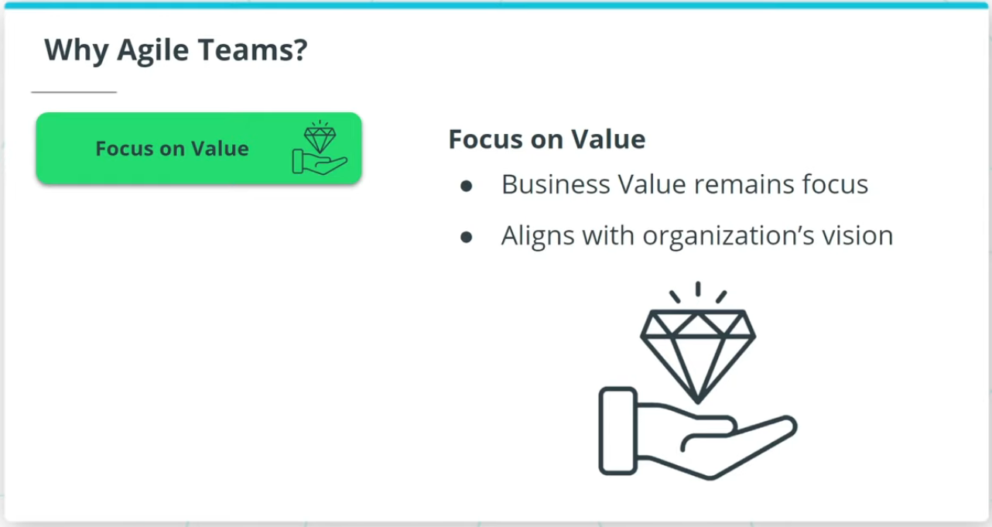

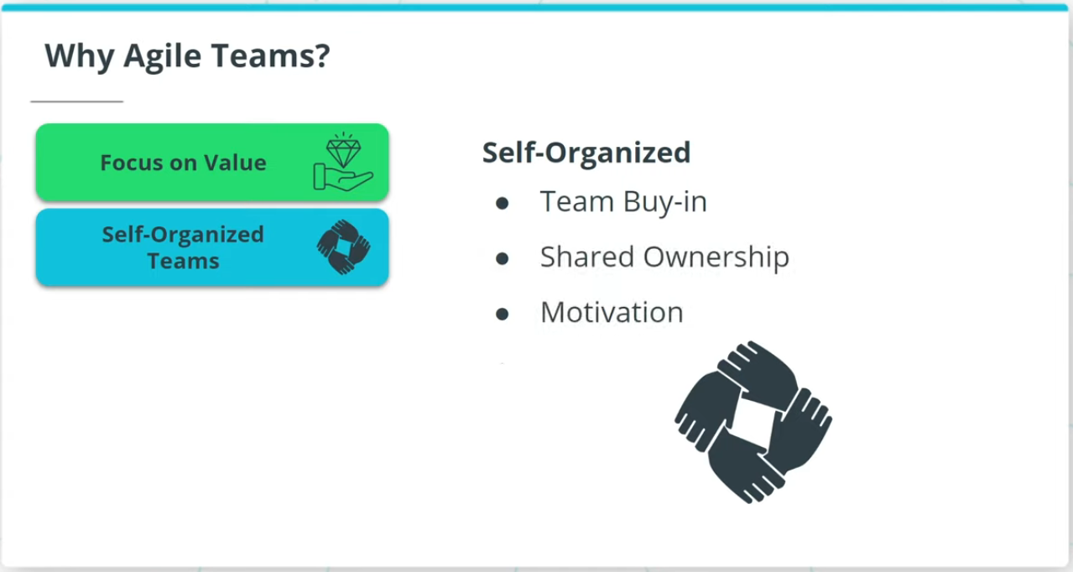

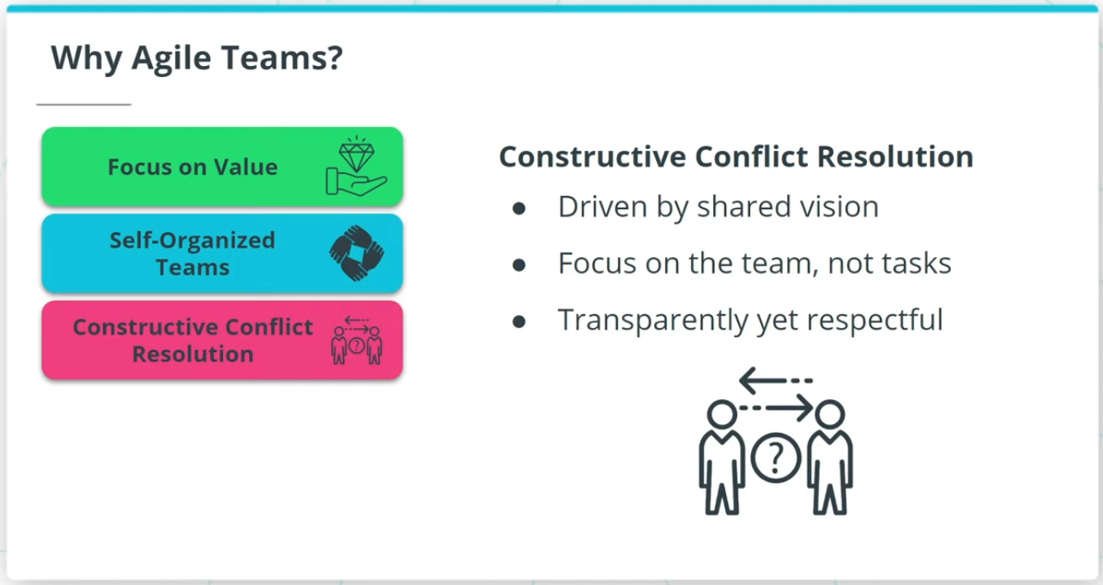

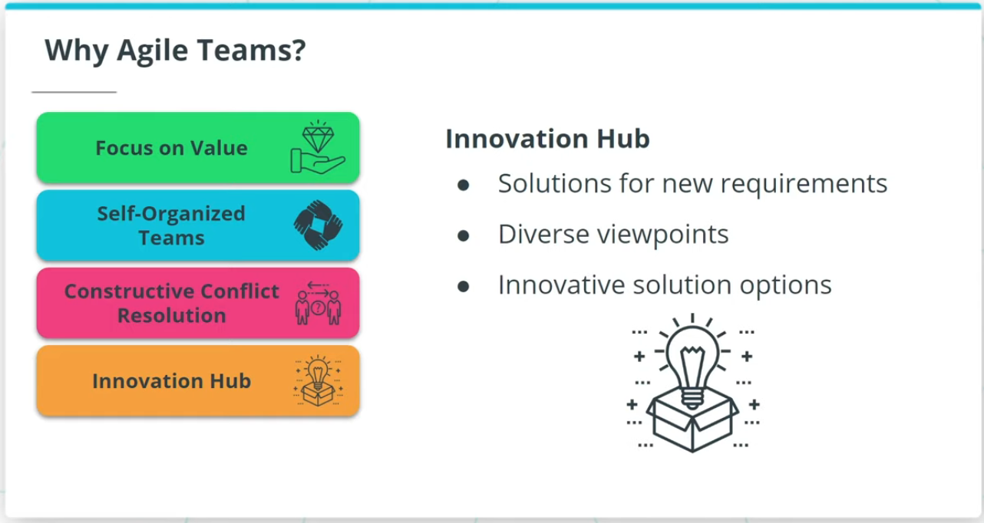

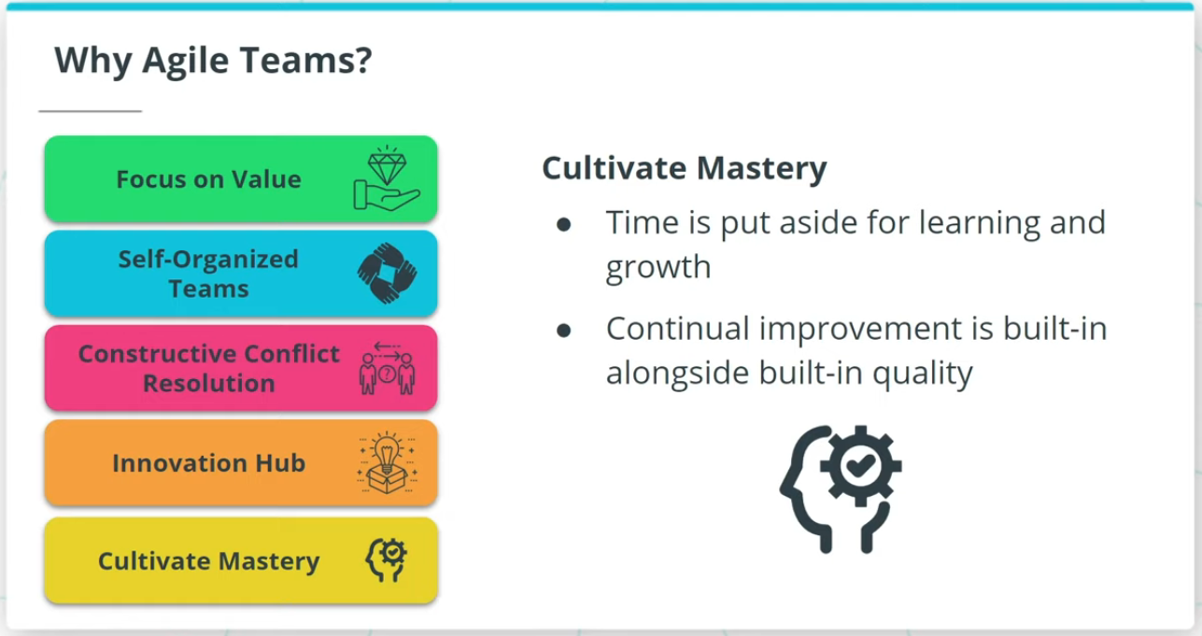

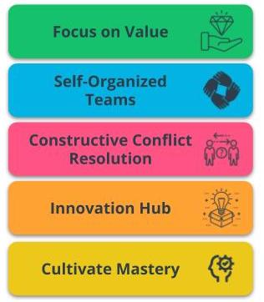

Benefits of Agile Teams

### **Agile Teams are a critical vehicle to deliver valuable results because of the following:**

* **Focus on Value** - Agile is driven by the goal of delivering maximum business value that is aligned with the organization’s vision.
* **Self-Organized Teams** - Agile Teams have the autonomy to make some de-centralized decisions, which allows for shared ownership of the work.
* **Constructive Conflict Resolution** - Conflicts in Agile Teams are constructively resolved because the team is driven by a shared vision.
* **Innovation Hub** - Agile Teams, with diverse and cross-functional skill sets, are an innovation hub that spurs solutions.
* **Cultivate Mastery** - Time is put aside in Agile Teams for learning and growth. This allows Agile Team members to sharpen their skills.

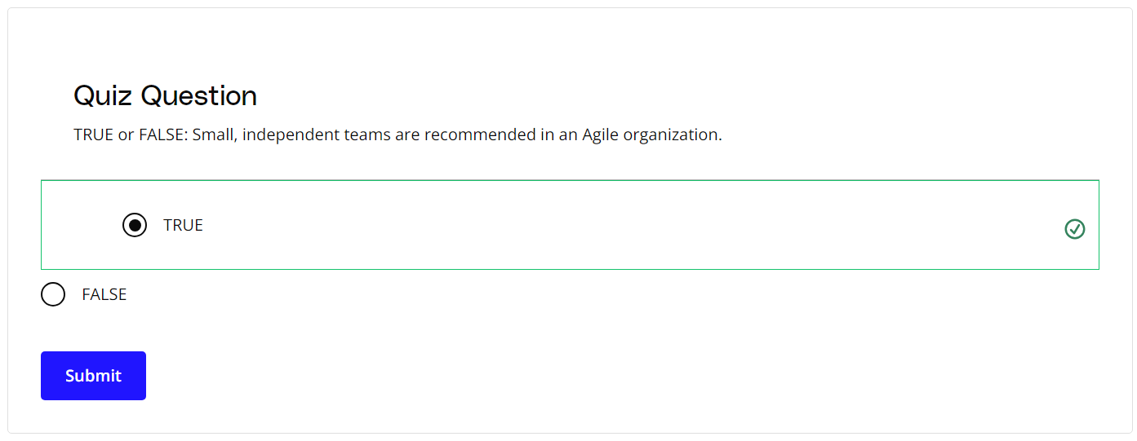

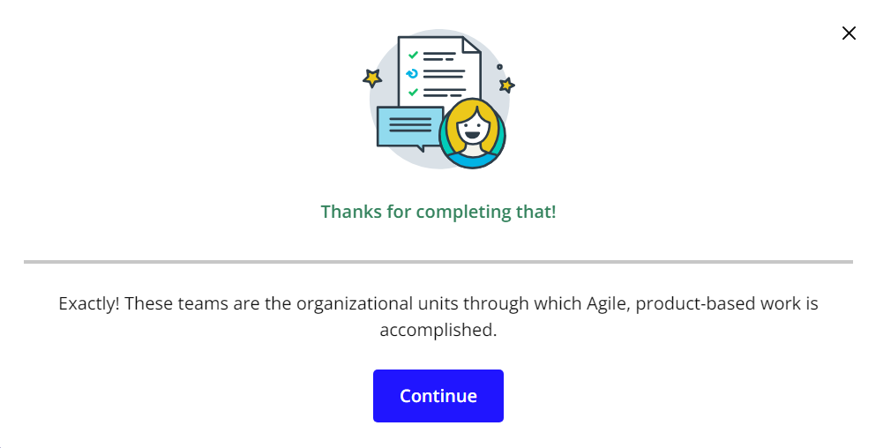

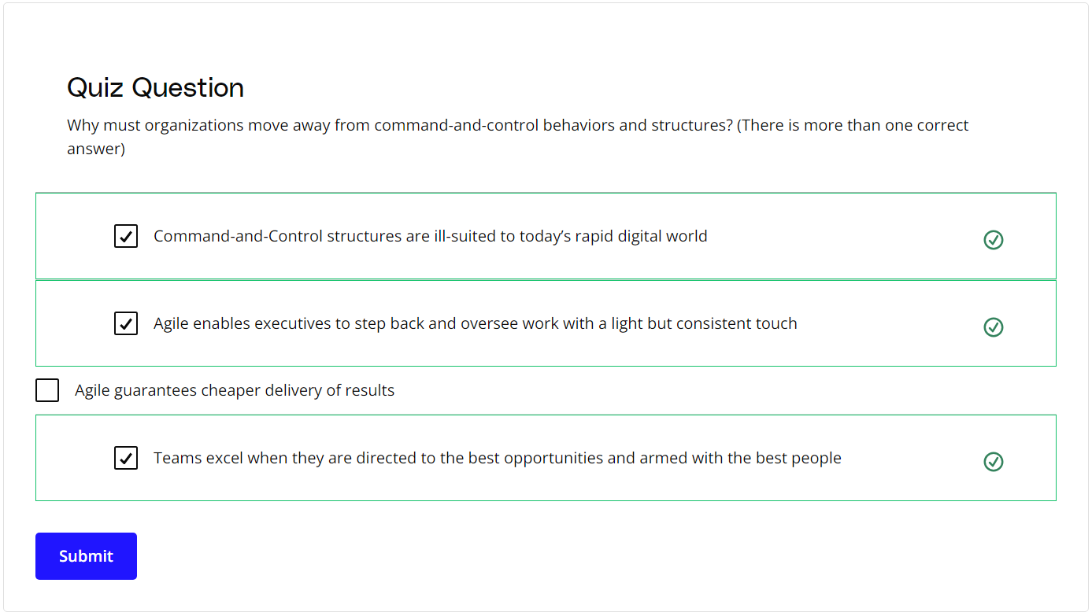

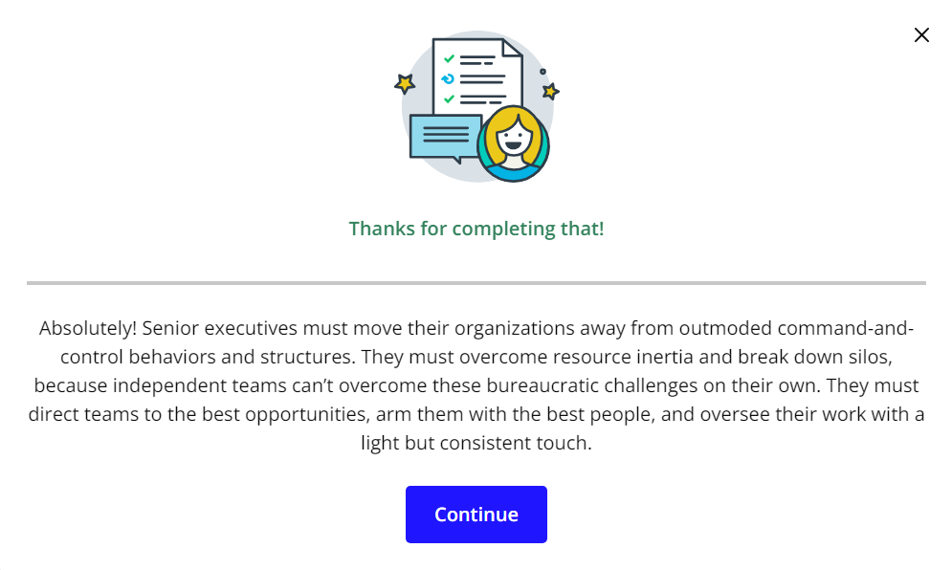

### **New Terms**

* **Innovation Hub**: Proactively working towards continual improvement with no compromise on technical excellence and quality
* **Self-Organized**: The team determines tasks and makes technical decisions about the work to be done after being given priorities by the Product Owner

### **Additional Resources**

* [**5 Ways to Organize Agile Teams**](https://www.scrumalliance.org/agile-resources/resources-for-your-agile-life/agile-advanced/may-2016/select-repost-5-ways-to-organize-agile-teams): This blog post from the Scrum Alliance describes five techniques to organize Agile teams successfully.

# How Experts Approach Agile Teams

## Thinking About Agile Teams

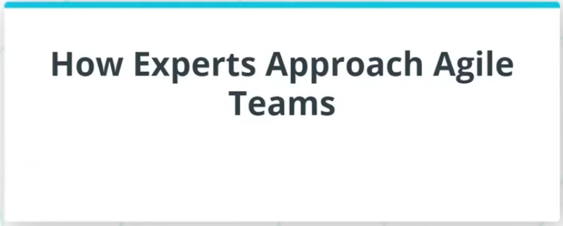

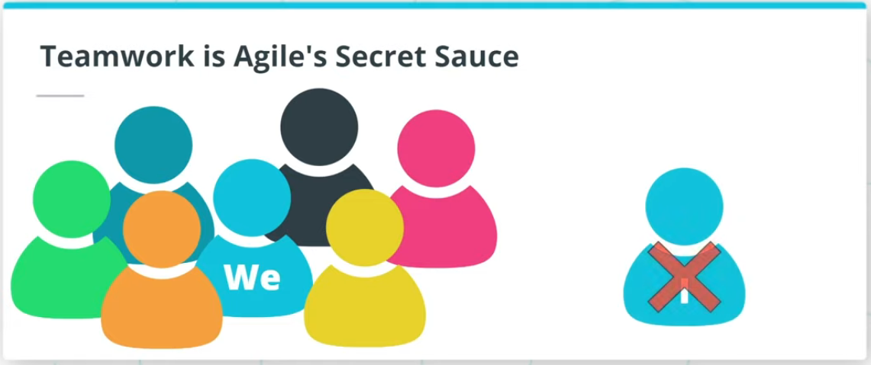

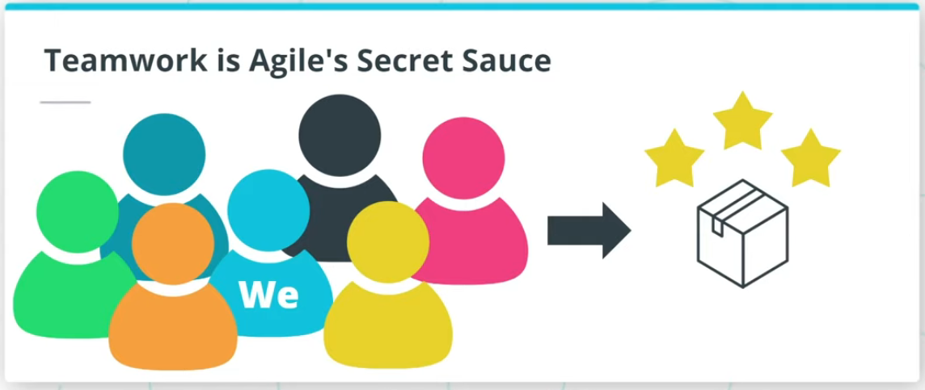

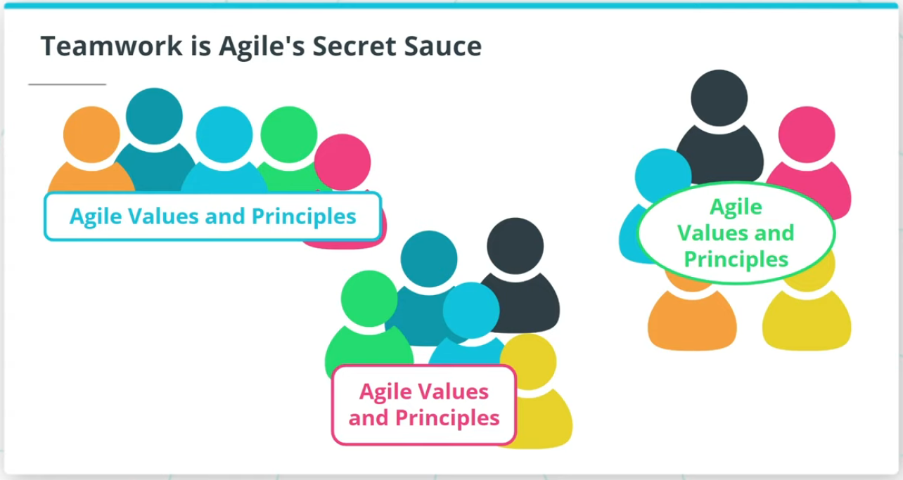

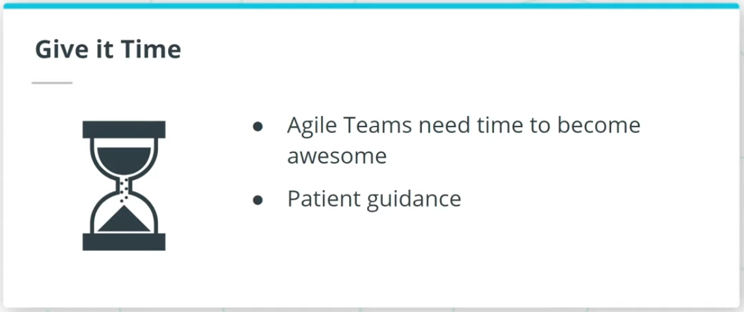

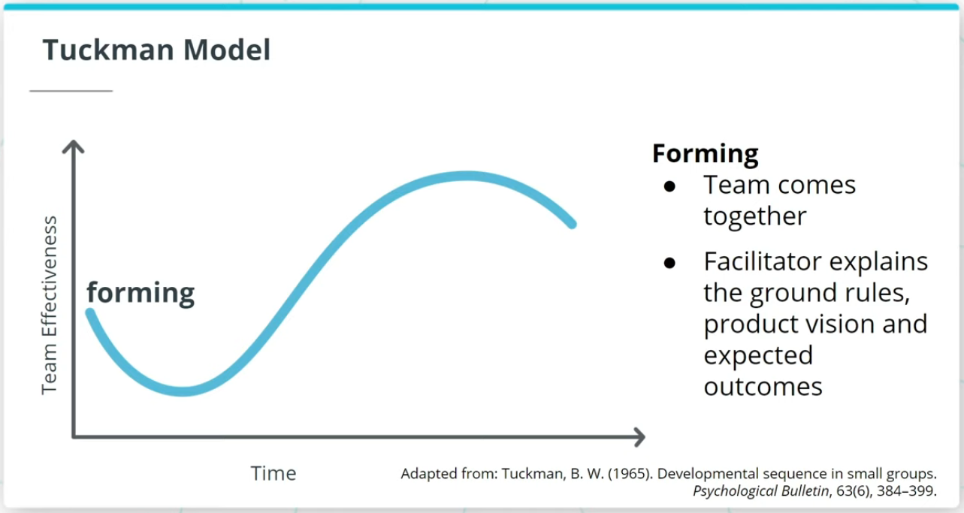

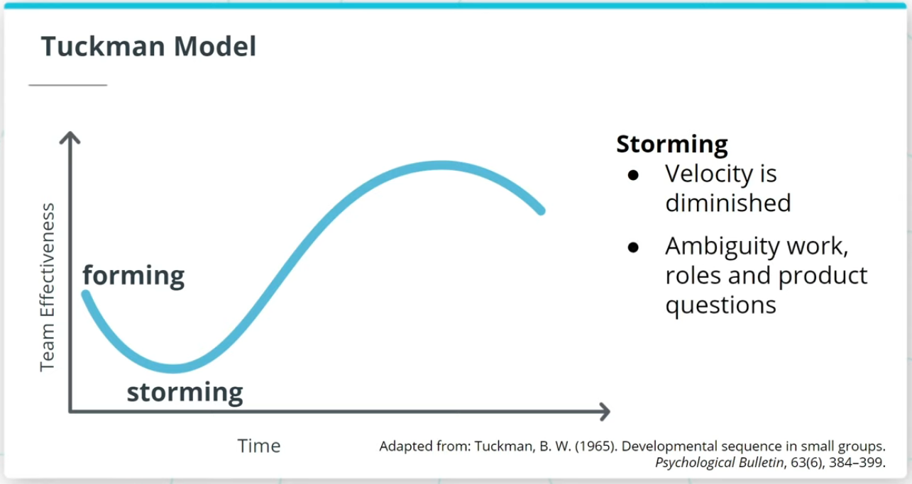

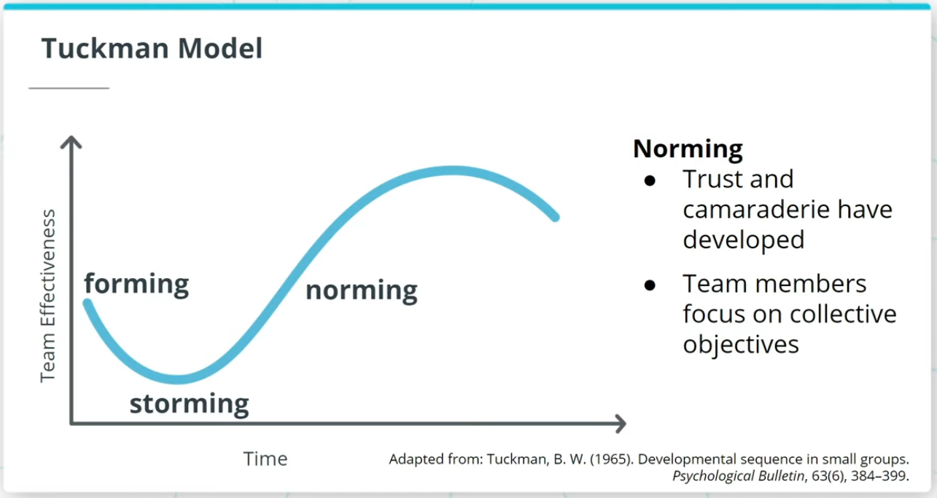

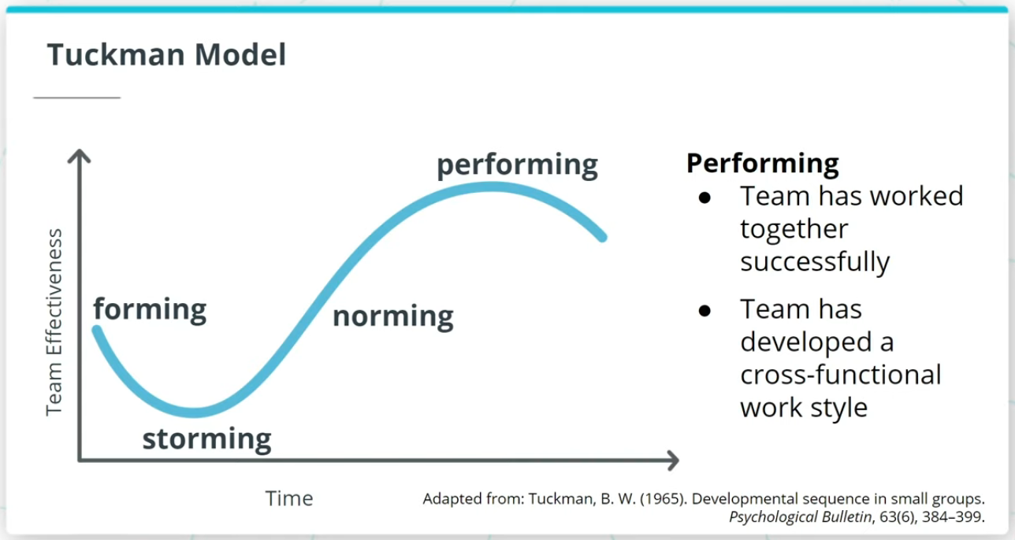

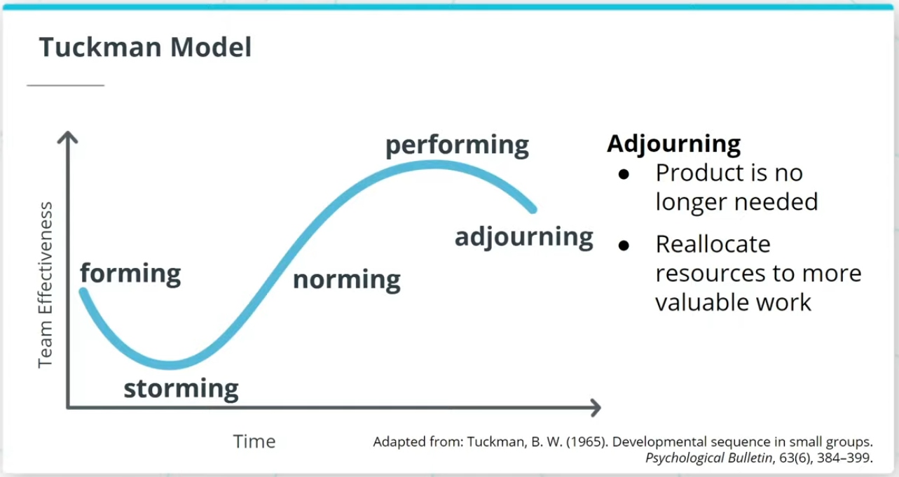

### **Key Points About High Performing Teams**

* Agilists believe that nothing is more critical to delivering exceptional products than teamwork.
* Agile Teams live and breathe the "we" mindset rather than “I."

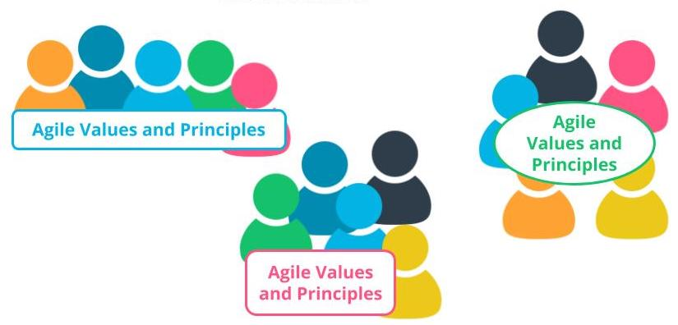

Teamwork is Agile's Secret Sauce

### **Tuckman Model**

The Tuckman Model, which has 5 stages of team development, describes how an Agile team progresses into an awesome Agile squad.

* **Forming** - Agile Team comes together and the Facilitator helps the team form by explaining the ground rules, product vision, and expected outcomes.
* **Storming** - This is where a team’s velocity is impacted because there tends to be some confusion and ambiguity around the work to be done, roles, and other product-related questions.
* **Norming** - Agile Team members develop a sense of trust and camaraderie. There’s a healthy rapport and each team member starts to look for the collective objectives of the team’s long-term success.
* **Performing** - Once an Agile Team has successfully worked together over a few iterations they should be in a state where they have gelled together and developed a strong cross-functional work style.
* **Adjourning** - If the business leaders realize that a product is not delivering value or is no longer needed in the market, the existing Agile Team members can be re-allocated to other more valuable work in the organization.

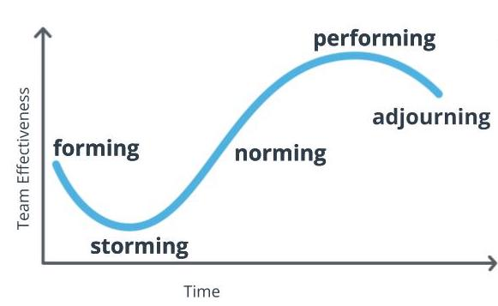

**The Tuckman Model**  
Adapted from: Tuckman, B. W. (1965). Developmental sequence in small groups. Psychological Bulletin, 63(6), 384–399.

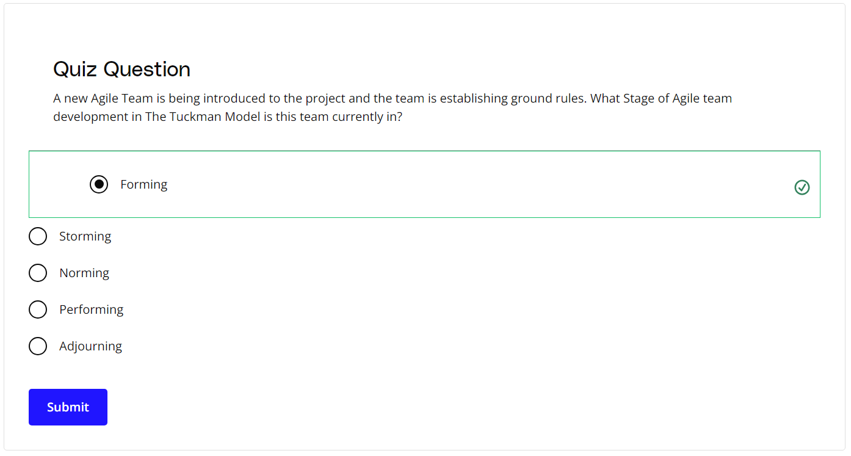

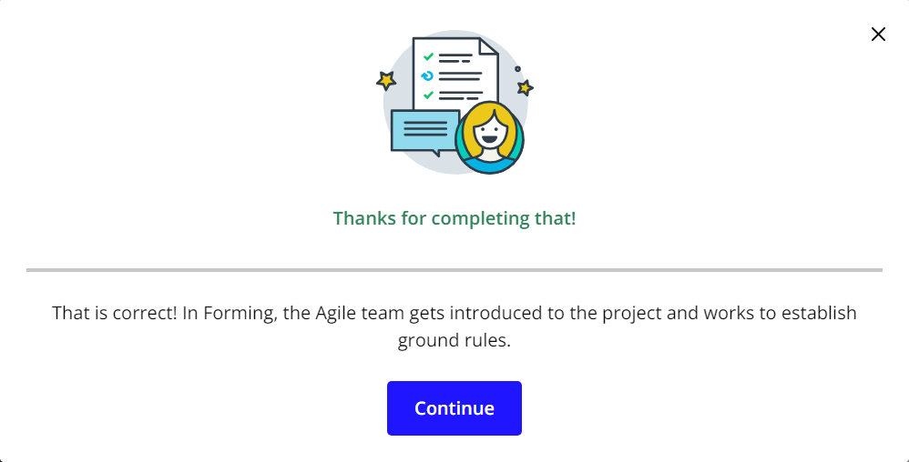

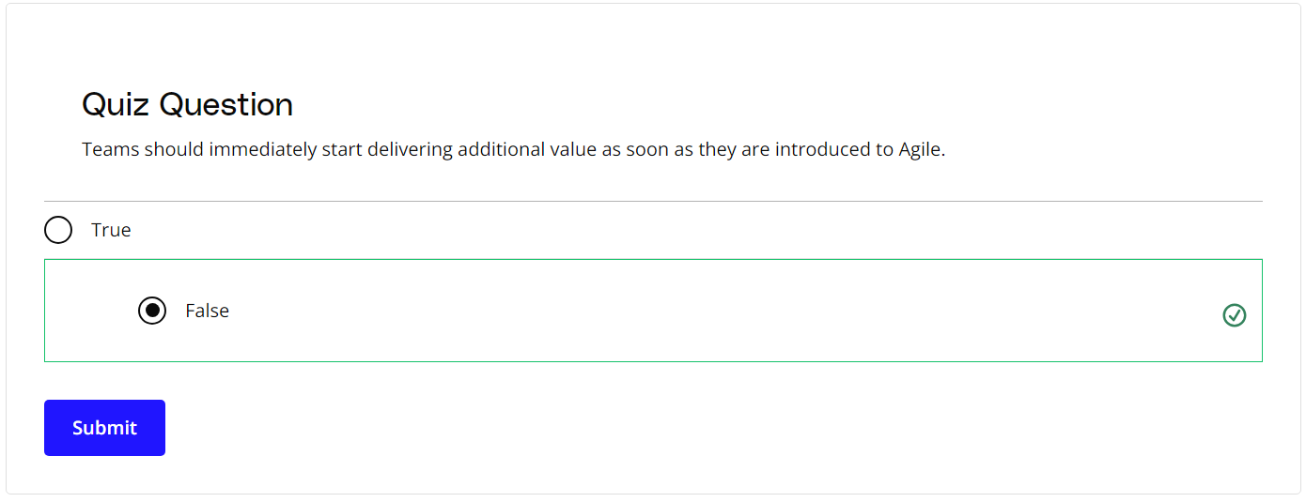

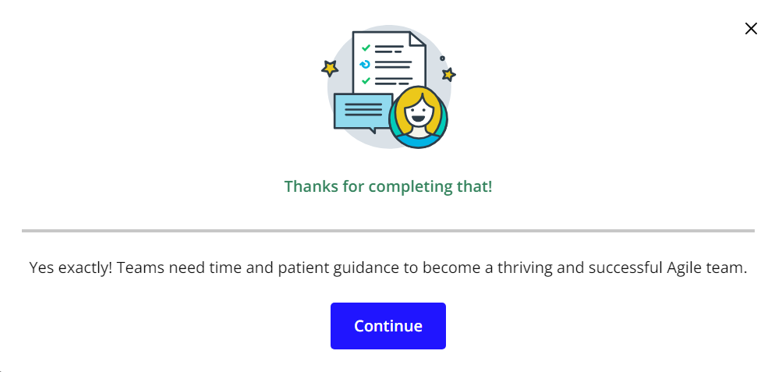

### **New Terms**

* **Adjourning**: The stage in the Tuckman Model where the Agile team’s goals have been completed, and the focus is on wrapping things up before team members get reassigned to other work
* **Forming**: The stage in the Tuckman Model when the team is getting accustomed to each other, ground rules are being established, and everyone is informed of the goals and objectives
* **Norming**: The stage in the Tuckman Model where a sense of trust develops among team members; interpersonal differences are taken care of now, and a sense of collaboration for the team's collective benefit arises
* **Performing**: The stage in the Tuckman Model where the team has matured into a well-established unit with a sharp focus on collaborative value delivery
* **Storming**: The stage in the Tuckman model where the team goes through a level of chaos in which there is confusion around the goals and objectives of the project, as well as confusion around roles and responsibilities

### **Additional Resources**

* [**High-Performance Teams - Why the Who Matters Less**](https://www.scrumalliance.org/agile-resources/resources-for-your-agile-life/agile-advanced/march-2017/high-performance-teams-why-the-who-matters-less): Fabian Schwartz discusses how the collective team is more important than having superstars on board.
* B W Tuckman, ***Developmental Sequence in Small Groups***, Psychological Bulletin 63, 1965.  
  This is where Bruce Tuckman first introduced the Tuckman Model.